DELHI TECHNOLOGICAL UNIVERSITY



STOCHASTIC PROCESSES

(MC-303)

PRACTICAL FILE

SUBMITTED TO:

PROF. H C TANEJA

MR. VINEET KUMAR

SUBMITTED BY:

NITYA MITTAL

(2K19/MC/089)

EXPERIMENT 8

# AIM

Demonstrating Markov Chain. WAP to find the n-step transition probability in case of a Markov Chain. Implement the same by considering a suitable example.

# THEORY

A Markov chain is a mathematical system that experiences transitions from one state to another according to certain probabilistic rules. The defining characteristic of a Markov chain is that no matter how the process arrived at its present state, the possible future states are fixed. In other words, the probability of transitioning to any particular state is dependent solely on the current state and time elapsed. The state space, or set of all possible states, can be anything: letters, numbers, weather conditions, baseball scores, or stock performances.

Markov chains may be modeled by finite state machines, and random walks provide a prolific example of their usefulness in mathematics. They arise broadly in statistical and information-theoretical contexts and are widely employed in economics, game theory, queueing (communication) theory, genetics, and finance. While it is possible to discuss Markov chains with any size of state space, the initial theory and most applications are focused on cases with a finite (or countably infinite) number of states.

## SOURCE CODE

i)

% Time Homogeneous Markov Chain

P = input('Enter the Transition Probability Matrix: ');

n = input('Enter the value of n: ');

i = input('Enter the current state: ');

j = input('Enter the future state: ');

P = P^n;

fprintf('The %dth step transition probability of going from step %d to %d is: %g', [n, i, j, P(i+1,j+1)]);

ii)

% Time Non-Homogeneous Markov Chain

n = input('Enter the value of n: ');

d = input('Enter the dimension of the matrix: ');

P = eye(d);

for i = 1:n

M = input('Enter the matrix: ');

P= P*M;

end

i =input('Enter the current state: ');

j = input('Enter the future state: ');

fprintf('The %dth step transition probability of going from step %d to %d is: %g', [n, i, j, P(i+1, j+1)]);

## OUTPUT

i)

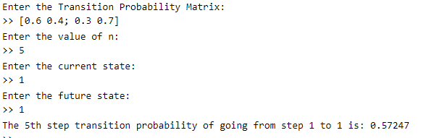

ii)

